**Peptic Ulcer Disease**

February 2013

Temple University School of Pharmacy

# Talitha L. Pulvino, PharmD, BCPS

[talitha.pulvino@temple.edu](mailto:talitha.pulvino@temple.edu)

**Learning objectives**

1. Discuss the pathophysiologic mechanisms involved with peptic ulcer disease
2. Be able to explain the process by which NSAIDs cause peptic ulcers
3. Given a patient case, identify risk factors associated with NSAID-induced ulcers
4. Briefly discuss the non-invasive diagnostic tests of Helicobacter pylori-associated ulcers
5. Given a patient case, recommend an appropriate Helicobacter pylori-associated ulcer eradication regimen and a test for eradication
6. Recommend appropriate ulcer healing regimens
7. Create patient-specific plans for primary and secondary prevention of NSAID-induced ulcers
8. Given a patient case, be able to adjust H2-receptor antagonist dose based on renal function
9. Give an appropriate PPI regimen for the treatment of an acute GI bleed
10. Given a patient case, determine if a patient is a candidate for SRMD prophylaxis and recommend appropriate therapy

|  |
| --- |
| Required textbook reading :  Pharmacotherapy: A Pathophysiologic Approach (eds. DiPiro et.al. 8th Edition, 2011), chapter 40  Most recent treatment guidelines:  Chey WD, Wong BCY, and the Practice Parameters Committee of American College of Gastroenterology. American College of Gastroenterology Guidelines on the Management of *Helicobacter pylori* infection. Am J Gastroenterol 2007;102:1808–1825.  Lanza FL, Chan FKL, Quigley EMM, and the Practice Parameters Committee of the American College of Gastroenterology. Guidelines for the Prevention of NSAID-Related Ulcer Complications. Am J Gastroenterol 2009;104:728-738. |

**Definitions:**

Peptic ulcer disease- disruption of mucosal integrity of the stomach and/or duodenum leading to a local defect or excavation due to active inflammation

*Helicobacter pylori (H. pylori)* - infectious bacteria that causes chronic gastritis in all infected individuals and is causally linked to PUD, gastric cancer, and mucosa-associated lymphoid tissue (MALT) lymphoma

Zollinger-Ellison Syndrome- rare disorder of gastric acid hypersecretion and recurrent peptic ulcers that result from a gastrin-producing tumor (gastrinoma)

**Peptic Ulcers**

**Ulcer**- break in the mucosal surface >5 mm in size with depth to the submucosa

* Gastric Ulcer (GU)
  + Occur later in life, peak incidence in 6th decade
  + More than half occur in males
  + Gastric acid output tends to be normal or decreased
* Duodenal ulcer (DU)
  + Death rates, need for surgery, and physicians visits have decreased by > 50% in the past 30 yrs
  + Gastric acid secretion tends to be increased

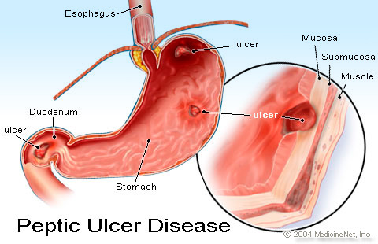

## Epidemiology

* Lifetime prevalence is about 12% in men, 10% in women
  + Recently rates declining for younger men, increasing rate for older women
* 15,000 deaths/year secondary to PUD
* Hospitalizations of older adults for ulcer-related complications (bleeding and perforation) have increased

## Pathophysiology

**Protective factors:** Gastroduodenal mucosal defense

* Pre-epithelial- first line of defense
  + Mucus
  + Bicarbonate
  + Surface active phospholipids
* Epithelial
  + Cellular resistance
  + Restitution
  + Growth factors, prostaglandins
  + Cell proliferation
* Subepithelial
  + Blood flow
  + Leukocyte

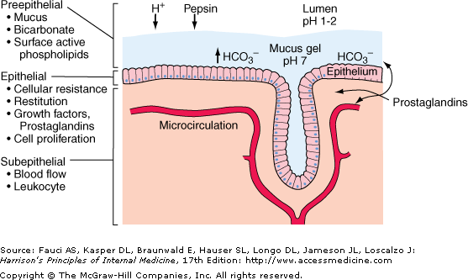

### Ulcer Etiology

* *H. Pylori*- Definition: infectious bacteria that causes gastritis; linked to PUD, gastric cancer, and mucosa-associated lymphoid tissue (MALT) lymphoma
  + Gram negative rod
  + Multiple strains exists
  + Believed to be transmitted from person to person; probably fecal to oral route
  + More common in older population
  + Higher prevalence in persons of lower socioeconomic status and people with less education
  + Almost always associated with chronic active gastritis
  + H. pylori is present in 30-60% of patients with GU, 50-70% of patients with DU
  + H pylori has enzyme “urease”. Digests urea into ammonia and CO2. Ammonia acts as buffer, and allows the h pylori to survive in acidic environment
* NSAID induced ulcers
  + NSAIDs have an inhibitory effect on cyclo-oxygenase COX-1, decreasing the production of prostaglandins and cause direct injury to the mucosa
  + Effects are systemic and local
    - Prostaglandins are a group of fatty acids that contribute to:
      * Mucosal defense
      * Platelet aggregation
      * Gastric blood flow
      * Reduction of acid output
    - Beneficial effects of NSAIDS on tissue inflammation are due to inhibition of COX-2. Toxicity of these drugs (GI ulceration) is related to inhibition of COX-1
  + Incidence of ulcers in NSAID users is up to 15-30%

GI Toxicity of NSAIDs (also include ASA)

More toxic

Less toxic

NSAID- induced ulcers: Risk factors

|  |  |
| --- | --- |
| **Established Risk Factors** | **Potential Risk Factors** |
| Age >60 y.o.  Previous peptic ulcer  Previous ulcer- related upper-GI complication  Chronic illness  High-dose NSAID  NSAID + ASA  NSAID + concomitant medication: corticosteroid, anticoagulant, antiplatelet, oral bisphosphonate, SSRI | H. pylori infection  NSAID-induced dyspepsia  Alcohol consumption  Cigarette smoking  Rheumatoid arthritis |

* Idiopathic ulcers
  + True incidence difficult to determine
  + Pathogenic mechanism unknown
  + Some may have hx of heavy NSAID use
* Zollinger-Ellison syndrome 20:00
  + A diagnosis of ZES is considered in patients with multiple ulcers and recurrent/refractory PUD
  + Ulcers occur most often in the duodenum
  + Diarrhea occurs in approx. 50% of patients due to high concentrations of acid overwhelming the duodenum's buffering capacity and damaging the mucosa

## Symptoms/Clinical Features

* Clinical s/sx are unreliable and not specific
  + About 80% of patients have dyspepsia; only 15% of those have PUD
  + Elderly patients may present with “silent ulcer”
  + NSAIDs may mask the pain of NSAID-induced PUD
  + Sharp, burning epigastric pain, point tenderness
  + Diffuse lower abdominal pain
  + Nocturnal pain that awakens patient from sleep
  + May be relieved or worsened by eating
  + May persist for days, weeks, months
  + Nausea/vomiting/anorexia which may lead to weight loss

## Alarm symptoms 23:00

* Bleeding
* Anemia or drop in Hgb
* Weight loss
* See physician ASAP!

## Diagnosis

**PUD**

* Upper GI radiography or
  + Costs less, has a greater availability, and greater safety, so it is often the initial diagnostic procedure in patients with suspected uncomplicated PUD
* Upper endoscopy. Radiography

**Diagnosis of *H. pylori***: Testing is indicated with active PUD, past hx of peptic ulcer, or gastric MALT lymphoma.

* **Invasive (endoscopic)**
  + Histology (>95% sensitive and specific)
    - Gold standard
    - Microbiological examination using various strains
    - Not recommended for initial diagnosis
    - Pros: permits classification of gastritis, tests for active *H. pylori* infection
    - Cons: Expensive, requires trained personnel, results are not immediate
  + Rapid urease (>90% sensitive and specific)
    - *H. pylori* urease generates ammonia causes a color change
    - Pros: Simple to perform, inexpensive, rapid results, tests for active H. pylori infection
    - Cons: False negative with recent PPI use, antibiotics, bismuth compounds
  + Culture (100% specific)
    - Culture of biopsy
    - Not recommended for initial diagnosis
    - Used after failure of second-line treatment
    - Pros: Allows for culture and sensitivity testing, tests for active *H. pylori* infection
    - Cons: Time consuming, expensive, dependent on experience, results are not immediate
  + Polymerase chain reaction
    - DNA amplification technique using biopsy
    - Presently restricted to research
    - Pros: Great specificity and sensitivity, allows for culture and sensitivity data
    - Cons: Methodology not standardized
* **Non-invasive**
  + Antibody detection
    - Detects IgG antibodies to *H. pylori* in whole blood (laboratory) or fingerstick (in office)
    - Pros: Can perform in laboratory (more accurate than in-office) or in office (quick, within 15 minutes), inexpensive, convenient, not affected by PPIs or bismuth
    - Cons: Less sensitive and specific than endoscopic tests, unable to determine if antibody is related to active or cured infection, antibody titers vary markedly between individuals and take 6 months to 1 year to return to the uninfected range, antibiotics given for unrelated indications may cure the infection but antibody test will remain positive, so not useful for early follow up
  + Urea breath test (95% sensitive and specific)
    - *H. pylori* urease breaks down ingested labeled C-urea, patient exhales labeled CO2
    - Exposure to low-dose radiation
    - Pros: Simple, rapid, tests for active *H. pylori* infection, Good for early f/u, useful before and after therapy
    - Cons: False negative with recent PPI use, H2Ras, antibiotics, bismuth compounds, results take about 2 days;
    - Withhold PPIs or H2RAs (1–2 weeks) and bismuth or antibiotics (4 weeks) prior to testing
  + Stool antigen (>90% sensitivity; >90% specificity)
    - Identifies *H. pylori* antigen in stool, leading to color change that can be detected visually or by spectrophotometer
    - Pros: Inexpensive, convenient, useful before and after therapy, tests for active *H. pylori* infection
    - Cons: antibiotics, bismuth, and PPIs may cause false-negative results, but to a lesser extent than with the urea breath test

*Test-and-treat* strategy 36:30

* Appropriate in patients < 55 years old who present with uninvestigated dyspepsia without “alarm features.”

## Pharmacologic therapy

* PPIs H2-receptor antagonists, and antibiotics presented previously
* Introduction of new agents:
  + Sucralfate- thought to form an ulcer-adherent complex at the ulcer site, protecting it against further attack
    - Inhibits pepsin activity and may increase production of prostaglandin and gastric mucus
    - Take on an empty stomach to prevent binding to dietary protein and phosphate
    - Use with caution in patients with renal failure
    - Adverse effects: constipation (uncommon)
    - DDIs: can alter the absorption of some drugs
      * Take other medications 2 hours before sucralfate
    - Available as an oral suspension (1 g/10 mL) or 1g tablets
  + Bismuth subsalicylate- possible ulcer-healing mechanisms include antibacterial effect, local gastroprotective effect, and stimulation of endogenous prostaglandins
    - May impart a black color to the stool and possibly the tongue (liquid preparation)
    - May cause salicylate sensitivity
    - Use with caution in older patients with renal failure
    - Adverse effects: few when taken as recommended
    - DDIs: tetracycline (bismuth may decrease the serum conc of tetracycline. Separate the dosing. Take the tetracycline 2 hours prior to admin the bismuth. Both are used to treat H.pylori)
    - Available as liquid (262 mg/15 mL or 525 mg/15 mL)
  + Misoprostol – prostaglandin used for prevention of NSAID-induced gastric ulcers (not maintenance Tx)
    - Adverse effects: diarrhea, abdominal cramping (dose-dependent)
    - Pregnancy category X
      * Used to induce labor in women with term pregnancy
    - Typical dose: 200mcg po three or four times daily with food
    - Must give at least 600 mcg/day for effect

## Treatment Goals

* *H. pylori*-positive ulcers- eradicate *H. pylori*, heal the ulcer, and cure the disease
* NSAID-induced ulcer- heal the ulcer as rapidly as possible
* Secondary
  + Preventing ulcer recurrence
  + Reducing ulcer-related complications
  + Well-tolerated, cost effective treatment

***H. pylori* eradication**

**First Line Regimens**

|  |  |  |
| --- | --- | --- |
| Regimen (discussed possible AE with each drug) also use “regional” regimen (ie clarithromycin resistance may be prevalent in specific areas, so you should use a different regimen in these instances) | Duration | Eradication Rates |
| amoxicillin 1g BID (diarrhea) **+**  clarithromycin 500mg BID **+**  PPI BID (except esomeprazole) “triple drug regimen” | 14 days | 70-85% |
| metronidazole 500mg BID (no EtOH “metallic taste”?) **+**  clarithromycin 500mg BID **+**  PPI BID (except esomeprazole) “triple drug regimen” | 14 days | 70-85% |
| Bismuth subsalicylate 525mg po 4 times daily **+** metronidazole (no EtOH) 250mg 4 times daily **+**  tetracycline 500mg 4 times daily (GI upset, photosensitivity) **+**  PPI BID (except esomeprazole-only once/day) or ranitidine 150mg BID | 10- 14 days (14 day Tx is preffered) | 70-90% |

*dexlansomprozole is NOT INDICATED and will not be in table!

*PPI doses: Lansoprazole 30mg BID, Omeprazole 20mg BID, pantoprazole 40mg BID, rabeprazole 20mg BID, esomeprazole 40mg daily

Combination products

1. Pylera (bismuth subcitrate potassium 140mg, metronidazole 125mg, tetracycline 125mg)
   1. Dose: 3 tabs four times daily + PPI BID
   2. No risk with ASA allergy
2. Helidac (2 bismuth subsalicylate 262mg chewable tabs, 1 metronidazole 500mg, 1 tetracycline 500mg capsule= 4 tabs/each dose)
   1. 14 prepackaged dosing blister cards
   2. Dose: one dose (4 pills) 4 times daily + PPI or H2RA BID

Option (requires validation in US, **not first line**) - sequential therapy:

PPI **+** amoxicillin for 5 days, then PPI **+** clarithromycin **+** metronidazole for 5 days

**Eradication confirmation: test of cure**

* Treatment fails in about 20% of patients
* Test at least 4 weeks after completion of treatment (due to possible PPI test interactions)
* Recommendations:
  + Asymptomatic patients: urease breath test or stool antigen test to confirm eradication
  + Symptomatic patients: repeat a course of antimicrobial and antisecretory Tx
    - Treatment fails in ~20% of patients

## Salvage Therapy for H. pylori eradication

For patients that fail triple and quadruple therapy

Bismuth subsalicylate 525mg po 4 x daily **OR** amoxicillin 1g BID **+**

Metronidazole 250-500mg po 4 x daily **OR** levofloxacin 250mg po BID **+**

Tetracycline 500mgpo 4 x daily **+**

PPI BID (except esomeprazole) or H2RA BID

**Case 1**

SW brings a prescription to your pharmacy. “I’ve got some infection in my stomach and an ulcer,” he tells you. His prescription says:

Esomeprazole 40mg po daily

Clarithromycin 250mg po BID

Amoxicillin po 1g BID

His profile has the following notations: h/o angioedema with lisinopril, allergy to eggs and penicillin.

What would you do before filling these prescriptions?

Investigate the PCN allergy: call MD to recommend changing amoxicillin to metroindazole

Clarithromycin should be 500 mg PO BID

You also notice that the doctor forgot the quantity for each medication. What is your recommendation for duration of therapy?

DOT = 14 days….

***NSAID-induced ulcers***

* Primary therapy
  + Discontinue NSAID use
* Consider alternative analgesic (acetaminophen, tramadol, narcotic analgesics, if appropriate)
* COX-2 inhibitor (ONLY Celebrex) may be used as an alternative to a nonselective NSAID- risk of adverse cardiovascular effects must be weighted against the benefits. Once you add ASA to COX2I, the reduced GI bleed rate benefit is null/void
  + Acid suppression or sulcrafate
* Secondary therapy
  + Prophylactic cotherapy- either a PPI or misoprostol; decreases ulcer risk and upper GI complications in patients taking nonselective NSAIDs
  + Combination products: NapraPAC (naproxen/lansoprazole combo) Vimovo (naproxen/esomeprazole combo)

**Oral drug regimens used to heal or maintain peptic ulcers: “pay attention to healing regimens!!!!” need reduced acid secretion to allow for the ulcer to heal**

|  |  |  |
| --- | --- | --- |
| **Drug** | **Duodenal or Gastric Ulcer Healing** | **Maintenance of Duodenal or Gastric Ulcer Healing** |
| Omeprazole PPI’s once in the morning on empty stomach | 20–40mg daily | 20–40mg daily |
| Lansoprazole | 15–30mg daily | 15–30mg daily |
| Rabeprazole | 20mg daily | 20mg daily |
| Pantoprazole | 40mg daily | 40mg daily |
| Esomeprazole | 20–40mg daily | 20–40mg daily |
| Cimetidine | 300mg four times daily | 400–800mg at bedtime |
| 400mg twice daily |  |
| 800mg at bedtime |  |
| Famotidine | 20mg twice daily | 20–40mg at bedtime |
| 40mg at bedtime |  |
| Nizatidine | 150mg twice daily | 150–300mg at bedtime |
| 300mg at bedtime |  |
| Ranitidine | 150mg twice daily | 150–300mg at bedtime |
| 300mg at bedtime |  |
| Sucralfate | 1 g four times daily | 1–2 g twice daily |
| 2 g twice daily | 1 g four times daily |

**Duration of Treatment for NSAID-induced ulcers**

* Ulcer healing: 4 weeks of PPI or
  + 6-8 weeks of H2RA or sucralfate
* PPI treatment extends to 8-12 weeks if NSAID is continued

**ZES treatment**- (Zollinger-Ellison Syndrome): high dose PPI- (she said “just know that you Tx with high dose PPI”) Omeprazole 60mg/day or equivalent in divided daily doses q8 or q12hrs

**Case 2**

BR’s endoscopy results reveal a gastric ulcer. She typically takes ibuprofen 600mg po TID for arthritis pain. Her primary care physician calls you for a treatment recommendation. What is your recommendation? STOP NSAID….keep PPI ongoing for at least 4 weeks (although we shouldn’t…..if we had continued the ibuprofen, than we would use the PPI for 8-12 weeks????)

## Algorithm/ Management pathway

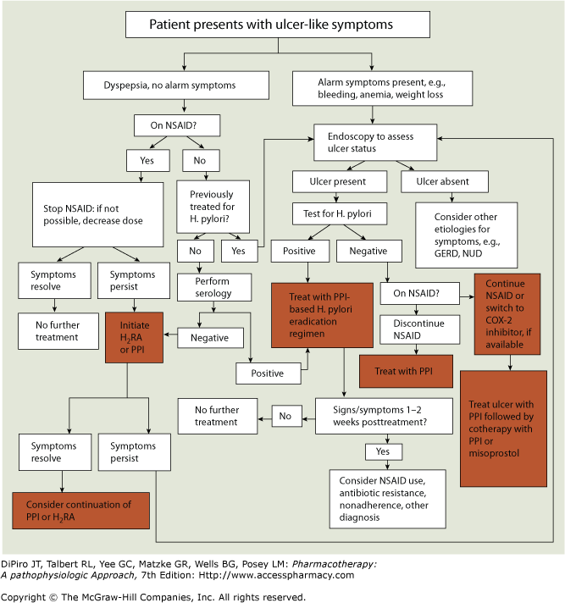

**Case 3**

Dr. C. calls you for a recommendation for his patient. The patient has been diagnosed with an NSAID-induced ulcer, but is on a fixed income without insurance.

Discuss how you would determine the most cost-effective treatment option regimen:

## Stop the NSAID, and initiate PPI Tx for 4 weeks (H2 antag used for 6-8weeks). Do the math: add up the price, and compare the cost of 4 weeks of PPI vs 6 weeks of H2A

**Clinical Pearls**

## Pain usually diminishes or disappears during treatment

## Recurrence of epigastric pain after healing often suggests an unhealed or recurrent ulcer

* PPIs are preferred to H2RAs or sucralfate for healing *H. pylori*-negative NSAID- induced ulcers because they accelerate ulcer healing and provide more effective relief of symptoms

## Non-pharmacologic tx/Lifestyle modifications

* Eliminate or reduce psychological stress and cigarette smoking (although not direct causes of ulcers; they are “risk factors”)
* Avoid foods and beverages (e.g., spicy foods, caffeine, and alcohol) that cause dyspepsia or that exacerbate ulcer symptoms
* Alternate methods for pain relief other than NSAIDs

## Complications 22:00

* GI bleeding
  + Most common complication
  + Occurs in about 10-15% of patients, more in patients >60 y.o.
  + Caused by the erosion of an ulcer into an artery
  + May be occult (hidden) and insidious, or may present as melena (black-colored stools) or hematemesis
  + The most important risk factor for upper GI bleeding is the use of NSAIDS (especially in older adults)
  + Deaths occur in patients who continue to bleed, or in patients who rebleed after initial bleeding has stopped
  + Treated with endoscopic therapy and/or drug therapy
    - High dose PPI infusion to keep pH >6 decreases further bleeding in patients with a high-risk bleed
    - Pantoprazole (NOT the omeprazole) 80mg IV bolus, followed by 8mg/hr infusion x 48-72 hrs
* Perforation 22:40
  + Occurs in 6-7% of patients
  + Incidence increasing with increased use of NSAIDs
  + Ulcer-related perforation into the peritoneal cavity
  + Mortality is usually higher for perforated gastric ulcer than duodenal ulcer
* Gastric outlet obstruction
  + Occurs in about 2% of patients
  + Mechanical obstruction is caused by scarring or edema of the duodenal bulb or pyloric channel and can lead to gastric retention
  + Perforation, penetration, and gastric outlet obstruction occur most often in patients with long-standing PUD

## Stress-Related Mucosal Damage (SRMD) 23:30

## (physiological STRESS ie result of burn complications, etc…not test anxiety stress)

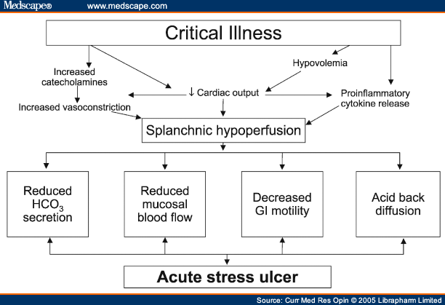

* Also called stress-induced ulcers or stress ulcers
* Goal of treatment is PREVENTION
* Risk factors- hospitalization and at least one of the following:
  + Respiratory failure needing mechanical ventilations for 48 hrs
  + Coagulopathy (INR >1.5 or PLT <50,000)
  + Anticoagulation
  + Hypotension
  + Severe burns (>35% of BSA)
  + Sepsis
  + Acute renal or hepatic failure
  + Multiple trauma
  + Severe head or spinal cord injury
  + H/o GIB
  + Major surgery (lasting >4 hrs)
* Prophylaxis regimens
  + H2-antagonist
    - Famotidine 20 mg PO/IV q12hrs
    - Ranitidine 150 mg PO q12hrs
  + PPI (PPI has not been proven superior)
    - Pantoprazole 40 mg PO/IV q24hrs
    - Omeprazole 20-40 mg PO (not IV) q24hrs (2 loading doses of 40 mg 6-8 hrs x 2 doses then 40mg q24hrs for Zegerid oral suspension)
  + Sucralfate 1g four times daily
  + Oral, feeding tube, or IV routes- switch from IV to enteral when able. IV is not more effective than oral route
  + Misuse of stress ulcer prophylaxis
  + Many hospitals use protocols or pathways to minimize misuse
  + Patients should be re-evaluated for SRMD risk periodically in critical care areas and when transitioning
  + Once risk factors are gone, therapy should be discontinued!

## Pharmacist’s Role

* No patient-directed therapy with PUD- patient must see a physician!
* Encourage compliance with regimens
* Hospital pharmacists may be involved in preventing misuse of SRMD prophylaxis
* All pharmacists can get involved with recognizing use of PPI or H2-antagonist where no longer indicated